**Naming Conventions**

##### Variables

Variable names should be concise and contain only lower case letters and underscores. Loop iterators should be short, preferably a single character.

**Classes**

Classes should be given descriptive names. Avoid using abbreviations where possible. Class names should always begin with an uppercase letter and be written in CamelCase even if using traditionally uppercase acronyms (such as XML, HTML). One exception is for Joomla Platform classes which must begin with an uppercase 'J' with the next letter also being uppercase.

For example:

* JHtmlHelper
* JXmlParser
* JModel

**Functions and Methods**

Functions and methods should be named using the "studly caps" style (also referred to as "bumpy case" or "camel caps"). The initial letter of the name is lowercase, and each letter that starts a new "word" is capitalized. Function in the Joomla framework must begin with a lowercase 'j'.

For example:

* connect();
* getData();
* buildSomeWidget();
* jImport();
* jDoSomething();

Private class members (meaning class members that are intended to be used only from within the same class in which they are declared) are preceded by a single underscore. Properties are to be written in underscore format (that is, logical words separated by underscores) and should be all lowercase.

For example:

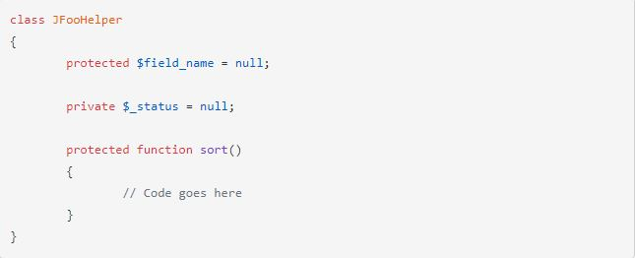

#### Namespaces

Namespaces are formatted according to this flow. First there is the file docblock followed by the namespace the file lives in. When required, the namespace is followed by the defined check. Lastly, the imported classes using the use keyword. All namespace imports must be alphabetically ordered.

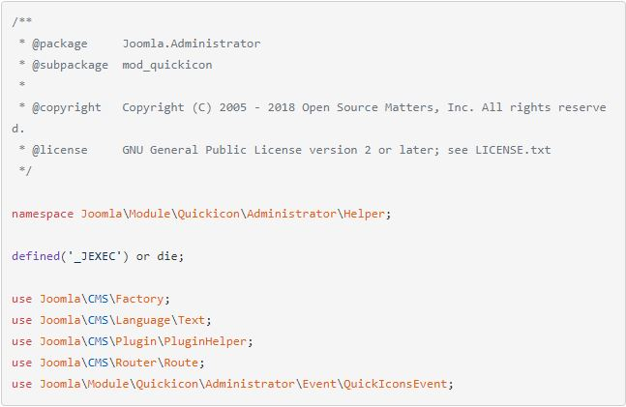

#### Constants

Constants should always be all-uppercase, with underscores to separate words. Prefix constant names with the uppercase name of the class/package they are used in. For example, the constants used by the JError class all begin with JERROR_.

MY_CONSTANT

TEMPLATE_PATH

TEXT_DEFAULT

#### Regular Variables and Class Properties

Regular variables, follow the same conventions as function.

Class variables should be set to null or some other appropriate default value.

### Exception Handling

Exceptions should be used for error handling.

The following sections outline how to semantically use [SPL exceptions](https://secure.php.net/manual/en/spl.exceptions.php).